A walking safari of sound and site

On your daily walk what do you see? Looking at the pictures below, can you tick when you see one? How many can you see or hear?
Picture | Tick | How many  Did you see?
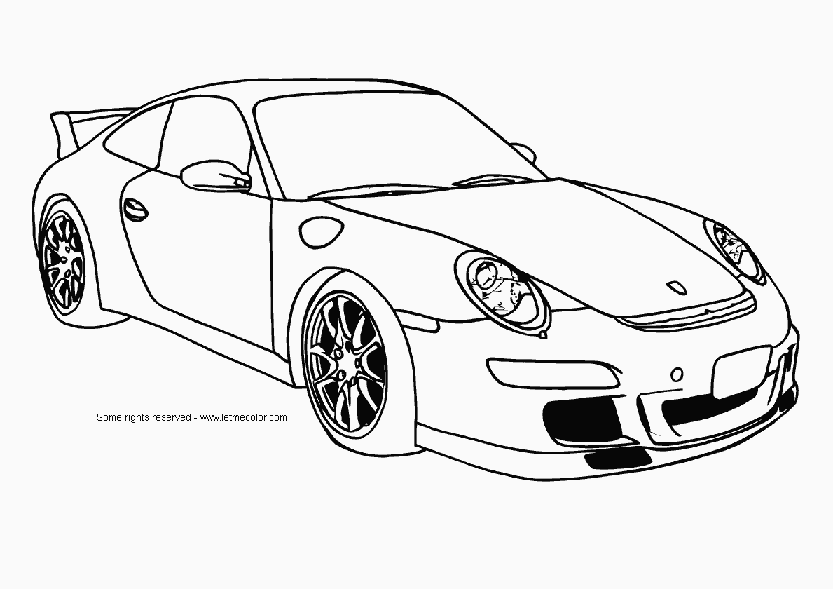
Car
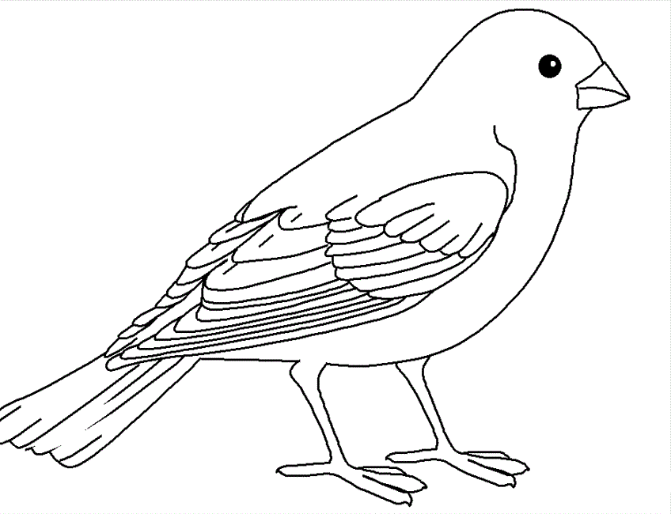
Bird
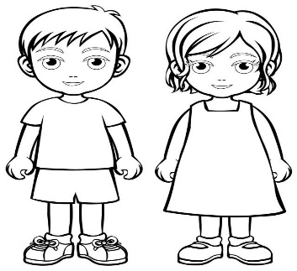
Children
Don’t forget to smile and say hello
Cat
Dog

Can you colour in the pictures?

