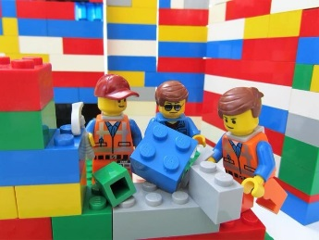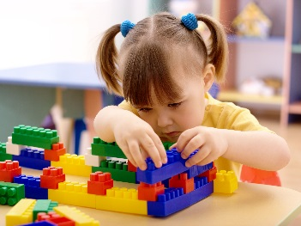
Quiet Time!
Let’s Play with Lego

Lego can be used to develop communication and social skills, as well as a wonderful resource for thinking and being creative.
Build a lego creation together.
I know it hard! But try not to take the lead, as adults we like things to match and look how we envisage, allowing your child to take the lead will keep them focussed for longer.
“Daddy’s turn, I’m putting mine here, your turn now” Taking in turns is another basic play skill that can be taught and reiterated during this time.
Below is an example of commenting and questioning and keeping the conversation going to extend language skills;
Parent – Why did you put the blue brick next to the green brick? (pointing as a visual prompt)
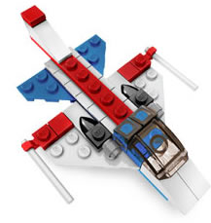
Child – Because that’s going to be the aeroplane
Parent – Why an aeroplane and not a helicopter?
Child – Because we went on an aerpolane last year on holiday
Parent – Yes we did, can you remember where to build the wings?
Child – Yes in the middle
Parent – How are you going to build the wings?
Child – With this one, look, it’s a funny shape
Parent - That is amazing, yes put it on the top, it does look like an aeroplane wing, good thinking, I’m so proud of you.
Keeping a conversation going will enable them to enhance their language skills and learn concepts such as prepositions (next to, infront, on top, behind). Praise them on their creation and give them a sense of achievement, keep it on show or until they need the bricks to build something equally as fantastically or even better.

Listening and attention game
We play this game at Preschool in small groups and it’s a fantastic way to gain your child’s attention, improve their listening skills, learn prepositions and maintain focus.
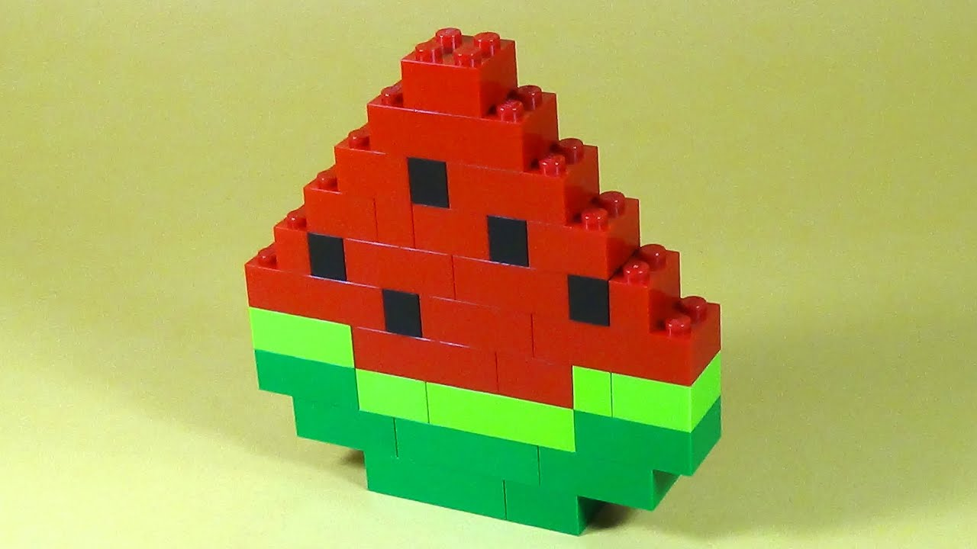
Put a pile of bricks on the table.
Give your child instructions, for example.
Parent Find a large red brick
Parent Put the small blue brick on top of the red brick
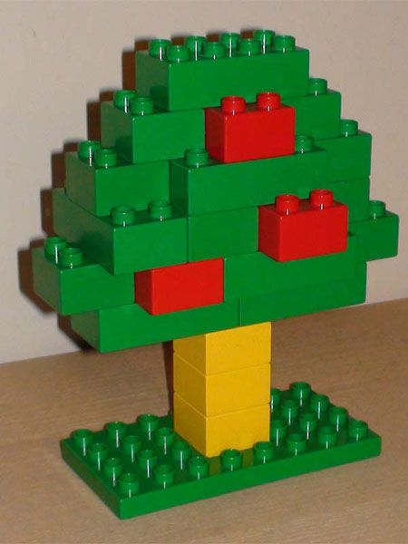
Parent Put a big yellow brick next to the red brick
Parent Join them up using a big green brick.
Etc. Until you have created what’s in your imagination.
Then, try it the other way round and let your child give you instructions.

